MAHARASHTRA STATE BOARD OF TECHNICAL EDUCATION, MUMBAI
A PROJECT REPORT ON
“REAL TIME GAS MONITORING SYSTEM”
UNDER THE GUIDANCE OF
“Ms. S. J. Patil”
DEPARTMENT OF COMPUTER ENGINEERING
DR.D.Y.PATIL POLYTECHNIC, KASABA BAWADA, KOLHAPUR
SEMESTER V YEAR: 2024-2025
SUBMITTED BY: G2
- Vaishnavi Ramesh Powar :- Roll no. 3104
- Asawari Bhanudas Pawar :- Roll no. 3105
- Swarali Sachin Patil :- Roll no. 3106
- Piyusha Hindurao Kesare :- Roll no. 3107
CERTIFICATE
THIS IS TO CERTIFY THAT G2 FROM DR. D. Y. PATIL POLYTECHNIC HAVING ENROLLMENT NO. 2205390242, 2205390073, 2205390216, 2205390127 HAS SUCCESSFULLY COMPLETED ‘PROJECT REPORT’ HAVING TITLE “REAL TIME GAS MONITORING SYSTEM” IN A GROUP CONSISTING OF 4 PEOPLE UNDER THE GUIDANCE OF MS. S. J. PATIL
.
Project guide
Head of Department
Principal

SEAL OF INSTITUTION
ACKNOWLEDGEMENT
We like to share our sincere gratitude to all those who helped us in completion of this Capstone Project Planning (CPP) Project Report. During the work, we faced many challenges due to our lack of knowledge and experience but our guides helped us to get over from all the difficulties and in final completion of our idea to a shaped sculpture.
We would like to thank Ms. S. J. Patil, her governance and guidance, because of which we were able to learn the minute aspects of Computer Engineering.
We would also like to show our gratitude to our Head of Computer Department Dr. P. K. Shinde for their continuous help and monitoring during the work. I am thankful to the supporting staff of our Department, for their help and support towards our project.
In the last we would like to thank the management of Dr. D. Y. Patil Polytechnic for providing us such an opportunity to learn from these experiences. We are also thankful to our whole class and most of all to our parents who have inspired us to face all the challenges and win all the hurdles in life.

DEPARTMENT OF COMPUTER ENGINEERING
ACADEMIC YEAR
2024-2025

DECLARATION

I, hereby declare that the Project Report entitled “REAL TIME GAS MONITORING SYSTEM” being submitted by us towards the partial fulfillment of the Diploma in Engineering, in the Department of Computer Engineering in Capstone project work carried by our team under the supervision of Ms. S. J. Patil.
We will be solely responsible if any kind of plagiarism is found.

Enrollment No. | Name of Student
2205390242 | Vaishnavi Ramesh Powar
2205390073 | Asawari Bhanudas Pawar
2205390216 | Swarali Sachin Patil
2205390127 | Piyusha Hindurao Kesare

ABSTRACT
This project report details the design and implementation of a real-time gas cylinder monitoring system utilizing Arduino technology. In households, gas cylinders are an essential source of fuel, yet managing their supply and ensuring safe usage can be challenging without effective monitoring. The proposed system addresses this need by providing continuous tracking of the cylinder's gas level. When the gas volume falls below a predetermined threshold, the system sends an alert to users, advising them to arrange a new cylinder before depletion, thereby ensuring uninterrupted gas availability.
Moreover, the system integrates a gas leakage detection module, which immediately identifies any gas escaping from the cylinder. Upon detecting leakage, the system issues an urgent alert to users, enabling timely intervention to prevent potential fire hazards and ensuring household safety. The entire system is powered by an Arduino microcontroller, which interacts with sensors to measure gas levels and detect leaks, processes data in real time, and triggers notifications.
Through this project, we demonstrate a practical, low-cost solution that enhances both the convenience and safety of gas cylinder management in homes. The system underscores the potential of embedded systems and IoT technology in developing user-centric applications that are both proactive and reliable in safeguarding essential daily processes

INDEX
Sr. No. | Title | Page no.
1. | Introduction and Background | 1
 | 1.1 Introduction | 1
 | 1.2 Background Work | 1
2. | Literature Survey | 2-4
 | 2.1 Related Work | 2
 | 2.2 Existing System | 3
 | 2.2.1Problems of Existing System | 3
 | 2.3 Problem Description | 3
 | 2.4 Goal And Objective | 4
 | 2.5 Application | 4
3. | Proposed Detailed Methodology | 5
 | 3.1. Proposed Methodology | 5
 | 3.2. Problem Definition | 5
4. | System Design Documentation | 6-7
 | 4.1. System Architecture | 6
 | 4.2. DFD | 7
5. | UML | 8-10
 | 5.1. Use Case Diagram | 8
 | 5.2. Block Diagram | 9
 | 5.3. Sequence Diagram | 10
6. | System Requirements | 11
 | 6.1. Hardware Requirements | 11
 | 6.2 Software Requirements | 11
7. | Action Plan | 12
8. | References | 13

- INTRODUCTION AND BACKGROUND:-

  - INTRODUCTION:
Gas cylinders are widely used for cooking and heating in households, as well as in various commercial and industrial applications. Despite their widespread usage, managing gas cylinders can be inconvenient and risky. Users often have no reliable way to gauge the remaining gas in the cylinder, leading to unexpected run-outs that can disrupt daily activities or business operations. Additionally, gas leaks, if undetected, pose serious safety hazards, including the risk of fires or explosions.

The "Real-Time Gas Cylinder Monitoring System Using “Arduino” is designed to address these challenges by automating the monitoring of gas levels and detecting potential gas leaks. This system employs a combination of weight sensors to monitor gas usage and gas sensors to detect leaks, providing real-time data and notifications to users. The system's goal is to offer a practical, affordable solution that enhances user convenience and safety by alerting them when the gas is nearly depleted or when a leak is detected.

  - BACKGROUND WORK:
With advances in the Internet of Things (IoT) and microcontroller technology, there is a growing trend toward automating various household and industrial processes. Arduino, an open-source microcontroller platform, has emerged as a popular choice for developing affordable and customizable automation solutions. This project takes advantage of Arduino’s versatility to create a real-time gas cylinder monitoring system that integrates weight-based and gas-leak detection sensors.

Current solutions available in the market for gas monitoring are either cost-prohibitive or lack integration of multiple safety features. Our project leverages the reliability and affordability of Arduino components, along with gas and weight sensors, to create a holistic system that continuously monitors the gas level and gas leak status.

- LITERATURE SURVEY:-
  - RELATED WORK:
Several studies and projects have focused on gas leak detection systems, gas level measurement systems, and IoT-based automation.

- Kalyani Bhagwat, Sanket Yende, Namrata Damare, Bhavesh Shah, and Prof. V.M. Umale (2023). ‘Smart LPG Gas Level Monitoring and Leakage Detection System using IoT’. Project Report submitted to Sant Gadge Baba Amravati University, Shri Sant Gajanan Maharaj College of Engineering, Shegaon, Maharashtra, India.
The "Smart LPG Gas Level Monitoring and Leakage Detection System using IoT" addresses safety and convenience issues in LPG usage by integrating IoT technologies. It employs sensors to monitor gas levels and detect leaks, notifying users via a mobile app and automated alarms. The system includes features like real-time gas level updates, automatic cylinder booking through the Blynk IoT platform, and safety alerts for leaks. It enhances independence and safety, particularly for elderly users, while being cost-effective and user-friendly. Future enhancements include voice alerts, Wi-Fi connectivity, and predictive analytics using machine learning.

- For instance, a study by “L. K. S. Rohan Chandra Pandey, Manish Verma, “Internet of things (IOT) based gas leakage monitoring and alerting system with MQ-2 sensor,” International Journal of Engineering Development and Research, Vol. 5, 2017.”
This paper by Rohan Chandra Pandey and Manish Verma discusses an IoT-based gas leakage monitoring and alerting system designed to improve safety by detecting and reporting gas leaks. Using the MQ-2 sensor, which is sensitive to gases like methane and LPG, the system continuously monitors the environment for potential leaks. When a leak is detected, the system triggers an alarm and sends alerts to users to prevent accidents and ensure quick response.

- P. M. Vidya, S. Abinaya, G. G. Rajeswari, and N. Guna, “Automatic lpg leakage detection and hazard prevention for home security,” in Proceeding of 5th National Conference on VLSI, Embedded and Communication & Networks on April, vol. 7, 2014.Research, Vol. 5, 2017.
The paper by Vidya, Abinaya, Rajeswari, and Guna presents a system for automatic LPG leakage detection aimed at enhancing home safety by quickly identifying gas leaks and initiating hazard prevention measures. The system is designed to detect leaks through sensors and immediately trigger an alarm to alert residents. Additionally, it includes mechanisms to shut off gas supply valves to prevent further leakage and reduce the risk of explosion or fire.This system leverages VLSI and embedded technology to enable efficient and responsive monitoring suitable for home environments. The research emphasizes the critical role of automation in home security, particularly for managing hazardous situations like gas leaks, and showcases how embedded systems can contribute to creating safer residential settings by responding quickly to potential threats.
We also referred to the following papers:
- Ravindra R. Hiwase, Priya K. Kewate, Sushmita P. Tajane, JitendraWaghmare “Automatic LPG Cylinder Booking and Leakage Detection using Arduino UNO” IJESC
- Mr. Akshay D. Prabhu, Mr. Ashwin D. Pathak, “Gas Leak Detector using Arduino UNO Microcontroller”, International Journal for Research in Applied Science & Engineering Technology (IJRASET), Volume 5, July 2017

  - EXISTING SYSTEM:
- Existing systems for gas cylinder monitoring are mostly manual or require costly, specialized equipment. The most common approach is a manual "shake test," where users shake the cylinder to estimate how much gas is left based on its weight. However, this approach is highly inaccurate and can lead to users being caught off-guard when the gas suddenly runs out.
- High-end automated systems, often found in industrial settings, provide accurate gas level readings and can detect leaks, but they are not affordable for the average consumer.
- These systems usually require a more complex setup, including industrial-grade sensors, centralized monitoring software, and skilled personnel for maintenance.

2.2.1. PROBLEMS OF EXISTING SYSTEMS:
Existing systems face several limitations:
- Inaccuracy of Manual Methods: Manual checks are unreliable, and users often run out of gas without prior warning.
- Limited Accessibility: Automated systems for gas monitoring are generally expensive, restricting their usage to industrial applications.
- Single-Functionality: Most systems are either dedicated to gas level measurement or leak detection, with few integrating both functions.
- Complex Installation: Industrial systems may require professional installation and maintenance, making them impractical for everyday household use.

  - PROBLEM DESCRIPTION:
The primary problems addressed by this project are:
- Unreliable Gas Level Monitoring: Users often cannot accurately gauge the remaining gas in their cylinders, leading to unexpected run-outs.
- Undetected Gas Leaks: Gas leaks are a serious safety hazard and can occur without warning, particularly if the user is unaware of a slow, continuous leak.
- High Cost of Existing Solutions: Affordable, integrated solutions for gas level and leak monitoring are largely unavailable, especially for residential and small-scale commercial settings.

  - GOAL AND OBJECTIVE:
The goal of this project is to develop a cost-effective, reliable, and easy-to-use gas cylinder monitoring system that:
- Notifies users when the gas level is low and replacement is needed.
- Detects gas leaks in real time to prevent safety hazards.
- Provides a comprehensive solution combining both functions at an affordable price, making it accessible to households and small businesses.

  - APPLICATION:
The proposed system has potential applications in:
- Households: To prevent the inconvenience of running out of gas during cooking and ensure safety through early leak detection.
- Restaurants and Food Services: Ensuring uninterrupted gas supply and maintaining safe cooking environments.
- Small-Scale Industries: Providing reliable gas supply monitoring to avoid disruptions in production processes and enhance worker safety.
- PROPOSED DETAILED METHODOLOGY:-
  - PROPOSED METHODOLOGY:
The system is based on an Arduino microcontroller, which serves as the core processing unit. Two main types of sensors are employed and also we will take help of Blynk App:

1) Load Cell with HX711 Module: The load cell is used to measure the weight of the gas cylinder, providing real-time data on the remaining gas level. The data from the load cell is amplified by the HX711 module, which is calibrated to calculate gas levels accurately. When the weight falls below a certain threshold, a low-gas alert is triggered.

2) MQ-2 Gas Sensor: The MQ-2 sensor detects the presence of combustible gases in the air. The sensor is calibrated to detect gases like propane and butane, commonly used in cooking. If the gas concentration exceeds a safe limit, the system triggers a leak alert.
The Arduino collects data from both sensors and processes it according to predefined thresholds. Notifications can be sent to users through a GSM module (for SMS alerts) or a buzzer (for on-site alerts), providing both remote and immediate alerts.
3) Blynk App: The Blink app enhances the real-time gas cylinder monitoring system by providing instant notifications for low gas levels, leak detections, and booking reminders. Users receive alerts when the gas is almost empty or if a leak is detected, allowing for prompt action. The app’s user-friendly interface also enables convenient real-time monitoring of gas status, ensuring safety and ease in managing gas supply.

  - PROBLEM DEFINITION:
This project addresses two key problems:
- Unreliable Gas Monitoring: By using a load cell, the system can monitor the gas level in real-time, ensuring timely notifications for refills.

- Gas Leak Detection: With the MQ-2 sensor, the system provides real-time leak monitoring, improving safety by alerting users of potential hazards.
- SYSTEM DESIGN DOCUMENTATION:-

4.1. SYSTEM ARCHITECTURE:
The architecture consists of the following components:
- Arduino: Central controller that processes data from sensors and manages alerts.

- Load Cell with HX711 with HX711 Amplifier module: Provides real-time measurement of gas cylinder weight, allowing for low-gas detection.
- Type: Strain gauge-based load cell
- Capacity: Available in various capacities like 5kg, 10kg, 20kg, etc.
- Sensitivity: Typically around 1mV/V
- Accuracy: ±0.03% of full scale
- Resolution: High precision up to 24-bit (when used with HX711 module)
- Output: Analog, amplified by HX711 to digital for Arduino
- Power Supply: 5V (through HX711 module)

- MQ-2 Gas Sensor: Detects gas leaks by monitoring the concentration of combustible gases.
- Target Gases: LPG, methane, propane, hydrogen, alcohol, and smoke
- Sensing Range: 200 to 10,000 ppm (parts per million)
- Response Time: Less than 10 seconds
- Operating Voltage: 5V
- Output: Analog (can also be set up for digital output with a threshold)

- Blynk App: Sends SMS or notification to alerts the users.

- Buzzer, Relay, LED: For on-site visual and auditory alerts in case of low-gas or gas-leak conditions.

The Arduino is programmed to continuously check sensor data and trigger alerts if threshold conditions are met.

4.2. DFD (DATA FLOW DIAGRAM):
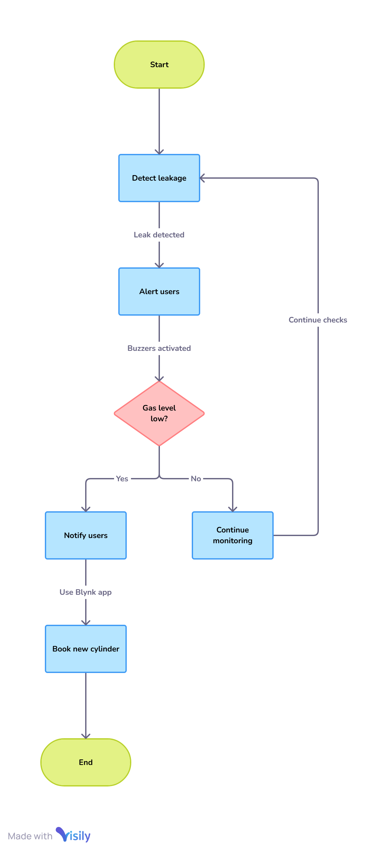
Fig. 1. Data Flow Diagram (DFD)
- UML (UNIFIED MODELING LANGUAGE DIAGRAMS):
5.1. USE CASE DIAGRAM:
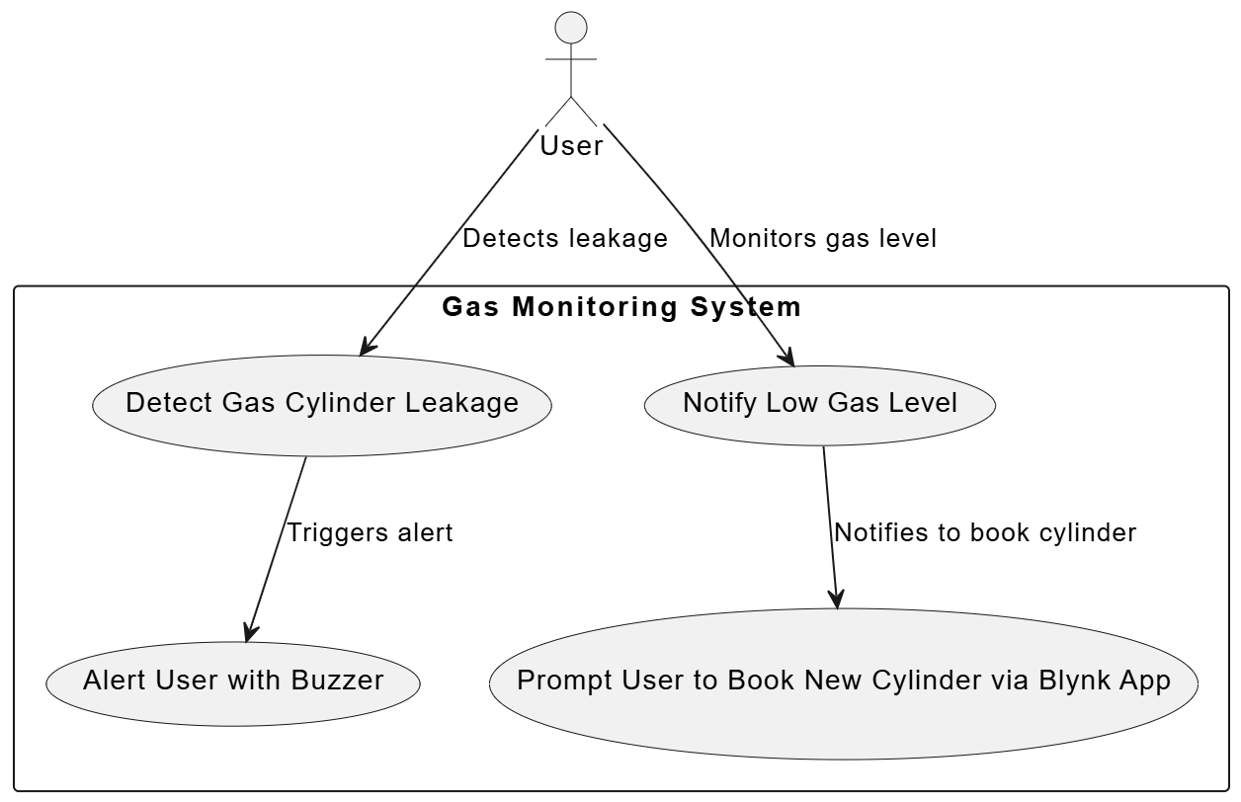
Fig. 2. Use Case Diagram
4.5. BLOCK DIAGRAM:
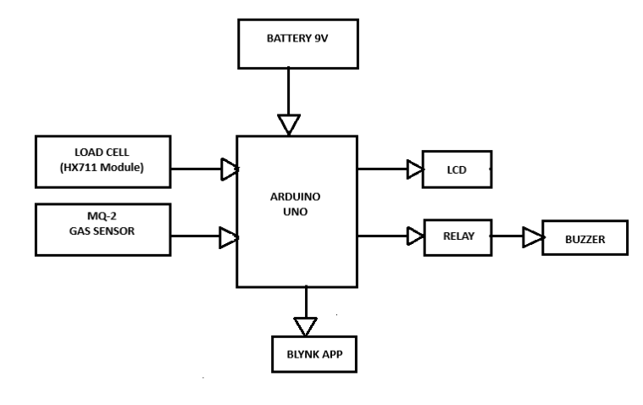Fig. 3. Block Diagram

4.6. SEQUENCE DIAGRAM:
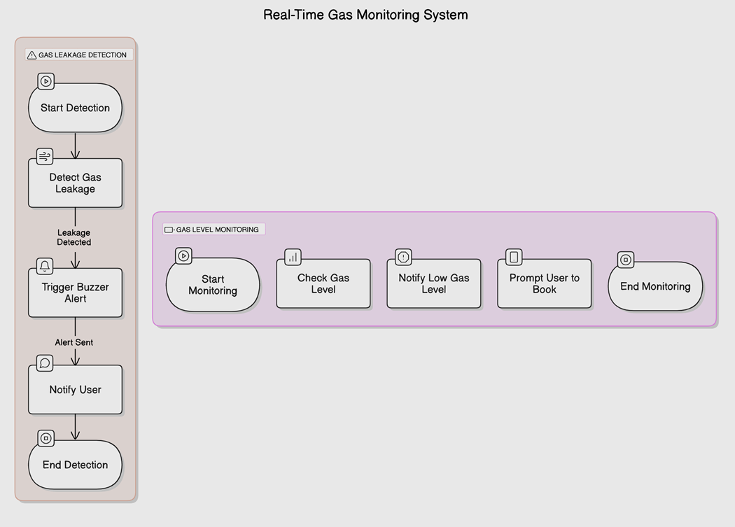
Fig. 4. Sequence Diagram

- SYSTEM REQUIREMENTS:-

6.1. HARDWARE REQUIREMENTS:

- Arduino: Microcontroller for data processing and control.

- Load Cell with HX711 Amplifier: Measures weight to determine gas levels.

- MQ-2 Gas Sensor: Detects gas leaks.

- Buzzer and LED: Provides on-site alerts.

- Power Supply: Powers the components.

6.2. SOFTWARE REQUIREMENTS:

- Arduino IDE: For coding and uploading programs.

- Libraries: Includes HX711, MQ-2 sensor libraries for interfacing sensors and modules.

- Blynk App: For sending SMS and notifications.

- ACTION PLAN:-

Sr. No. | Details of Activity | Start Date | Finish Date
1. | Started gathering information about multiple topics as information given  By our guide. | 15 July 2024 | 19 July 2024
2. | Started gathering information about the 5 topics that we selected as  Information given by our guide. | 22 July 2024 | 26 July 2024
3. | Finalize our topic name that is” REAL TIME GAS MONITORING  SYSTEM”. | 29 July 2024 | 2 August 2024
4. | We gathered details from our project guide and started working on it. | 5 August 2024 | 9 August 2024
5. | Searched for many reference links | 12 August 2024 | 16 August 2024
6. | Distributed task like searching about gas leak sensor and gas weight  Measurement sensor. | 19 August 2024 | 23 August 2024
7. | Started planning to choose which components other than sensors are used  While making gas monitoring system. | 26 August 2024 | 30 August 2024
8. | Started to collect information about which microcontroller is used and  Collecting the information about various microcontrollers. | 2 September 2024 | 6 September 2024
9. | Decided Arduino as the microcontroller being used. | 9 September 2024 | 13 September 2024
10. | Searched information of how we can use sensors with Arduino and  How to program it. | 16 September 2024 | 20 September 2024
11. | Gathered all the required hardware and software that are needed in our  Project. | 23 September 2024 | 27 September 2024
12. | Started searching for a platform for displaying details of our iot device and  Selected Blynk App. | 30 September 2024 | 4 October 2024
13. | Built a virtual model of how we will arrange our components. | 7 October 2024 | 11 October 2024
14. | Started searching information about the language that we can use for our  Ardunio. | 14 October 2024 | 18 October 2024
15. | Started working on the programming of our Arduino using C++. | 21 October 2024 | 25 October 2024
16. | Started working on the model of our real time gas monitoring system. | 28 October 2024 | 30 October 2024

- REFERENCES:-
- Kalyani Bhagwat, Sanket Yende, Namrata Damare, Bhavesh Shah, and Prof. V.M. Umale (2023). ‘Smart LPG Gas Level Monitoring and Leakage Detection System using IoT’. Project Report submitted to Sant Gadge Baba Amravati University, Shri Sant Gajanan Maharaj College of Engineering, Shegaon, Maharashtra, India.
- P. M. Vidya, S. Abinaya, G. G. Rajeswari, and N. Guna, “Automatic lpg leakage detection and hazard prevention for home security,” in Proceeding of 5th National Conference on VLSI, Embedded and Communication & Networks on April, vol. 7, 2014.Research, Vol. 5, 2017.
- L. K. S. Rohan Chandra Pandey, Manish Verma, “Internet of things (IOT) based gas leakage monitoring and alerting system with MQ-2 sensor,” International Journal of Engineering Development and Research, Vol. 5, 2017.
- Ravindra R. Hiwase, Priya K. Kewate, Sushmita P. Tajane, JitendraWaghmare “Automatic LPG Cylinder Booking and Leakage Detection using Arduino UNO” IJESC
- Mr. Akshay D. Prabhu, Mr. Ashwin D. Pathak, “Gas Leak Detector using Arduino UNO Microcontroller”, International Journal for Research in Applied Science & Engineering Technology (IJRASET), Volume 5, July 2017

